- Super admin - Trial & Automation- The system will provide a configurable free trial plan for newly registered gyms. The trial duration can be fully controlled by the Super Admin and can be set to any period (e.g., 7 days, 15 days, 30 days, etc.)
Subscription Plans & Feature Management
Automation & Global Settings
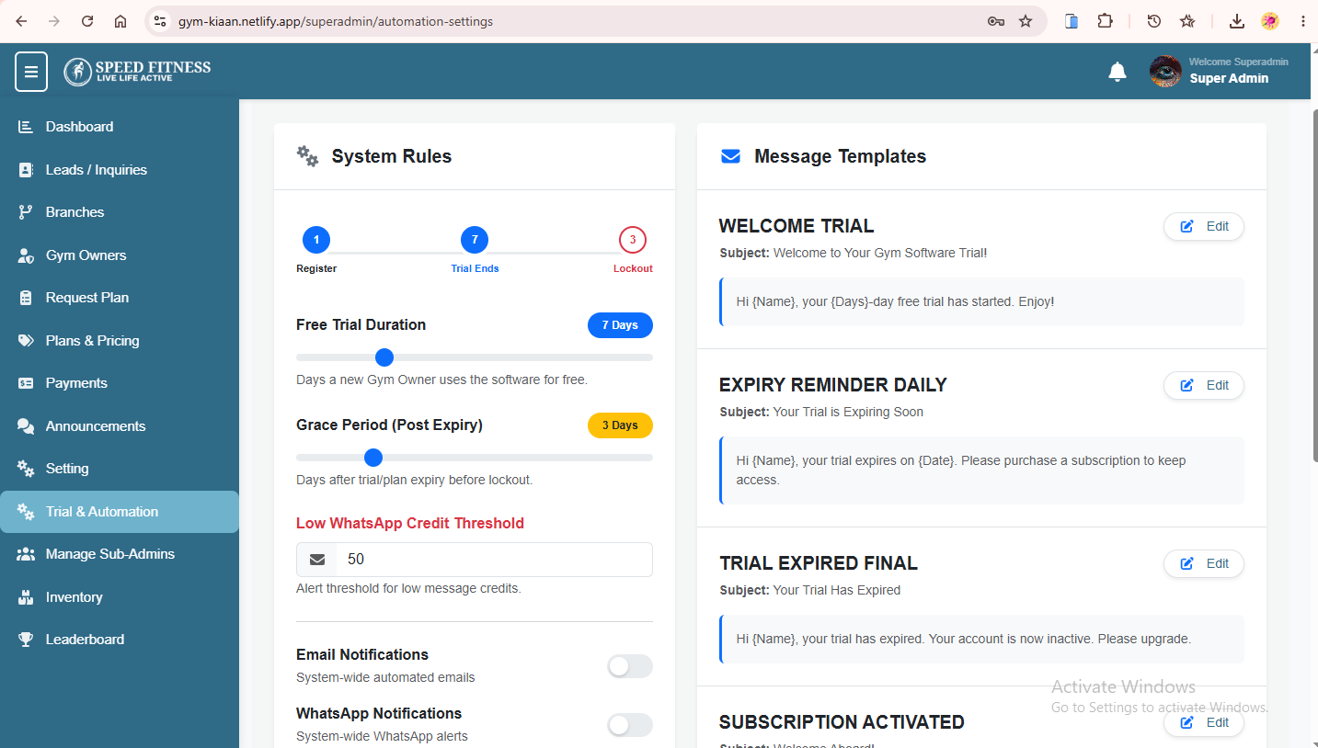
- Equipment & Inventory
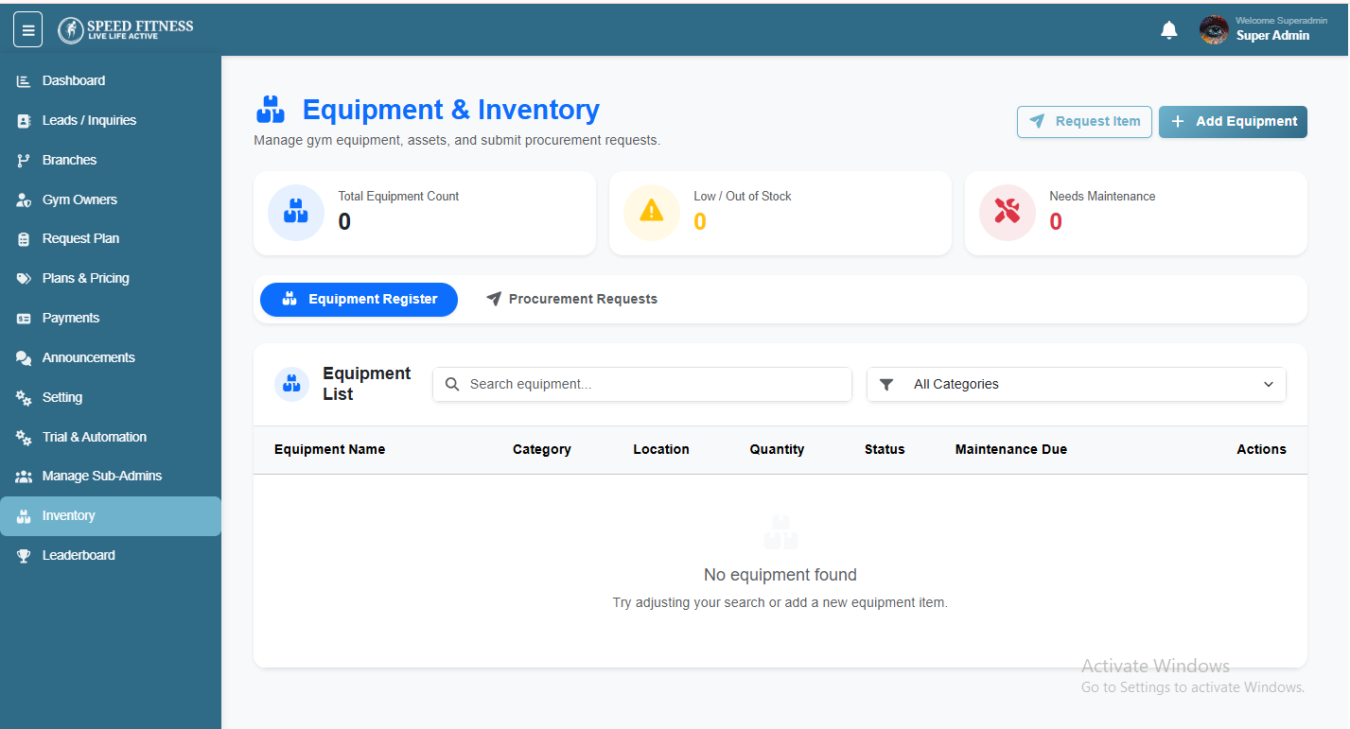
- Leaderboard – superadmin - multibranch filter button 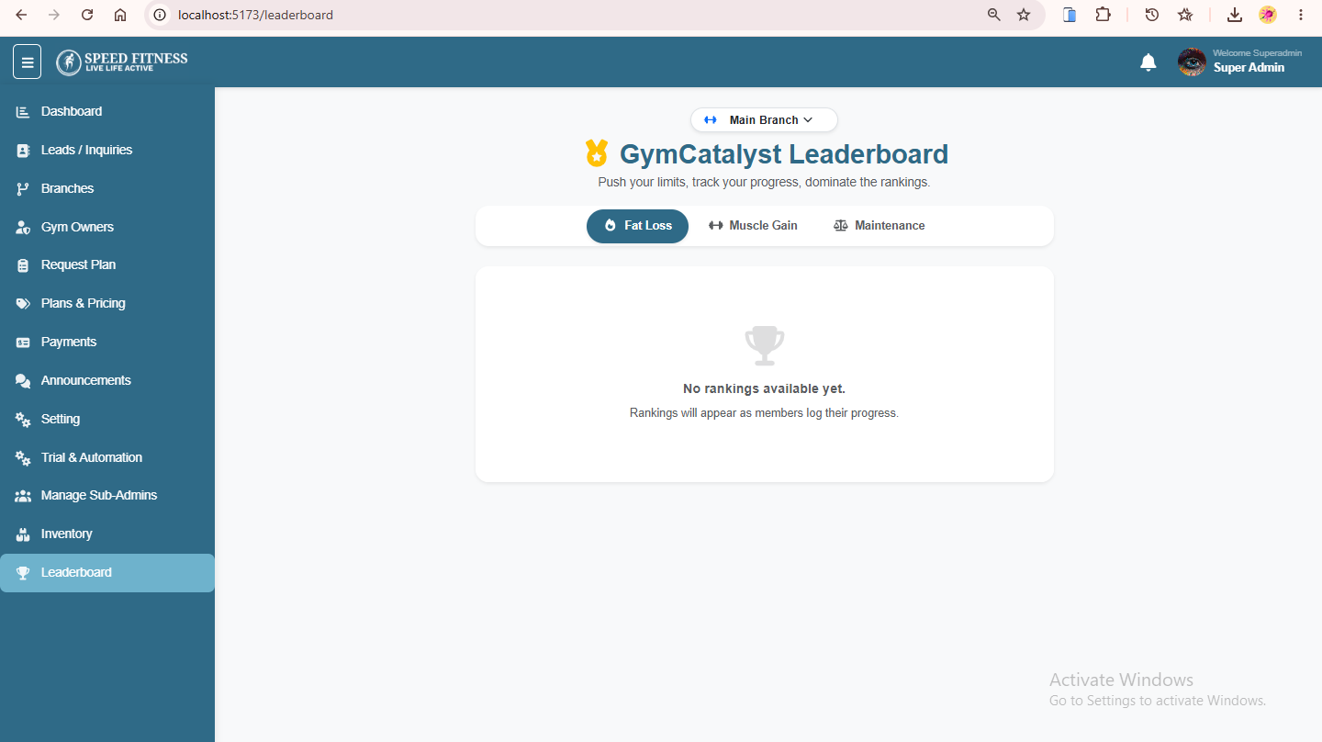
- Admin - leaderboard
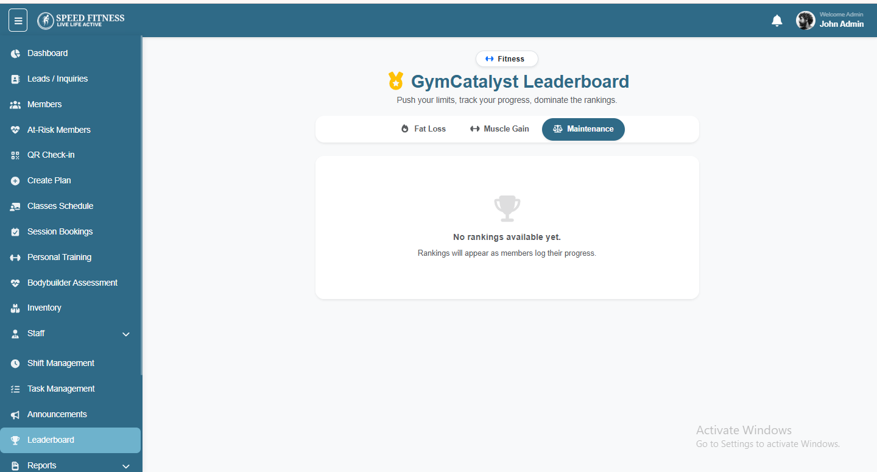
- At-Risk Members -The system will automatically categorize members based on their attendance percentage and send alerts to both members and gym administrators via selecting setting options for notification to be sent via in built App/webapp or whts app messages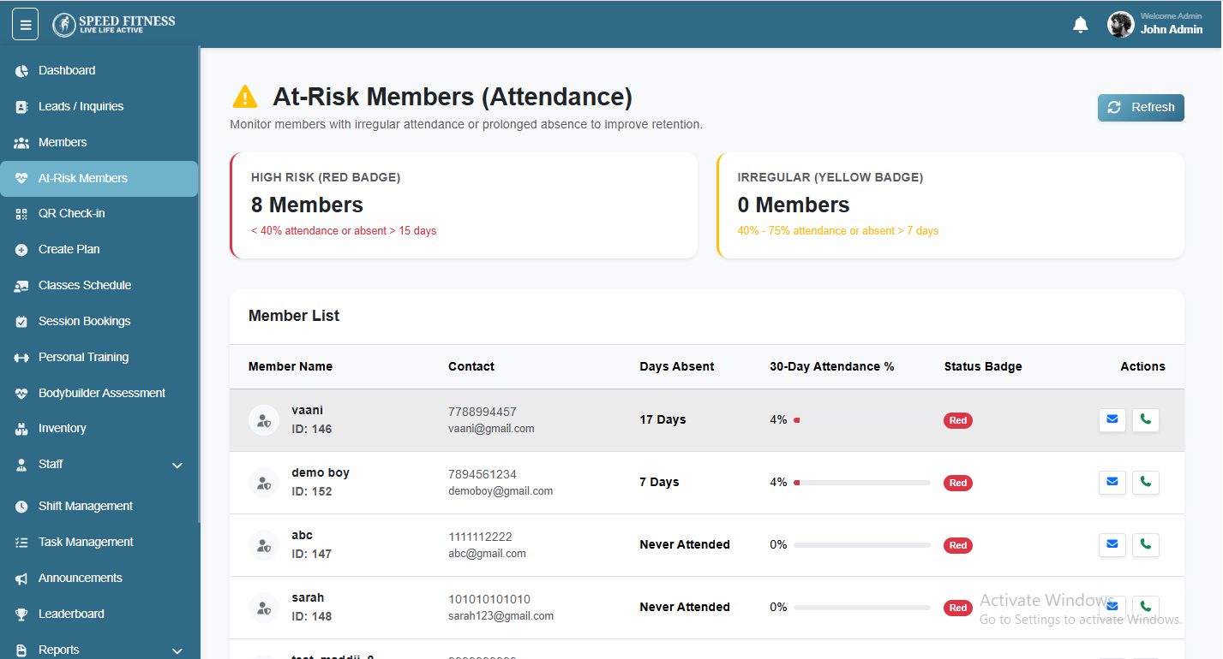

- Bodybuilder Assessment
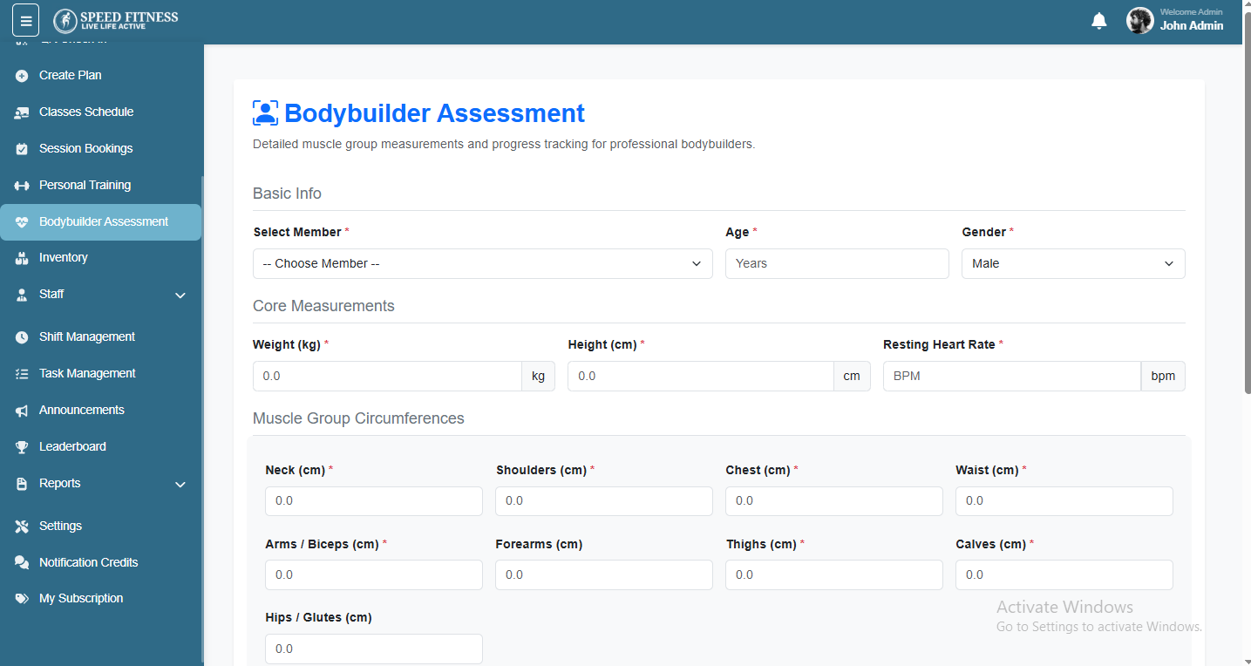

- Announcements & Notifications
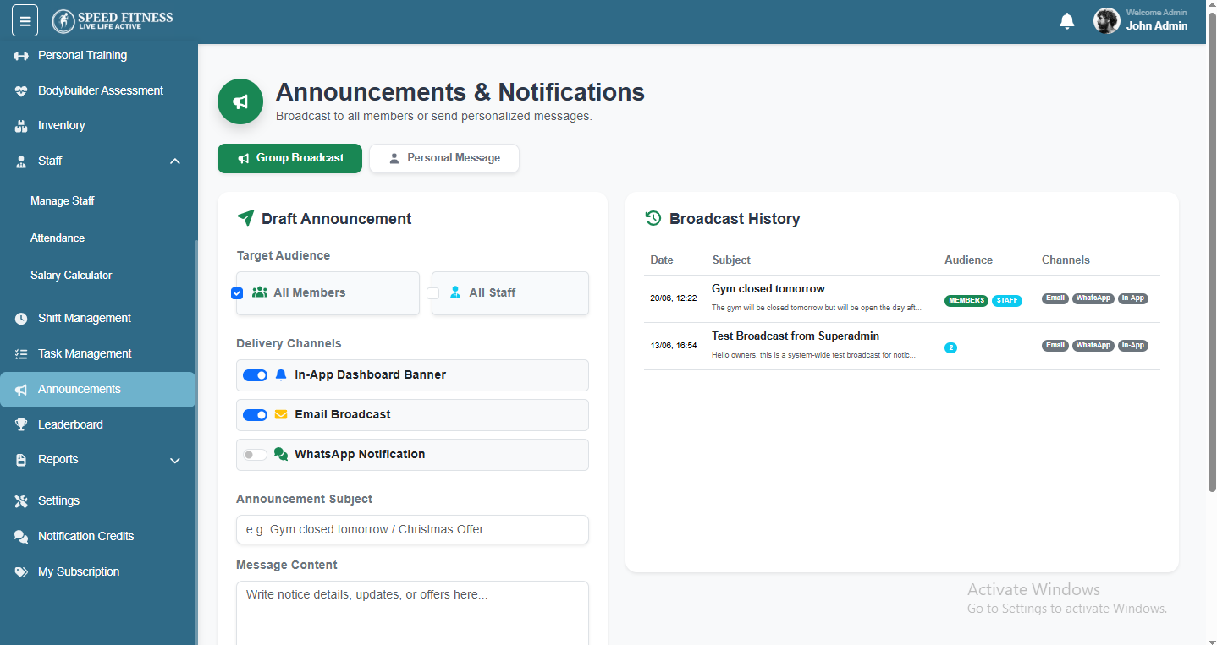

- Notification Credits - Notification & Message Credits

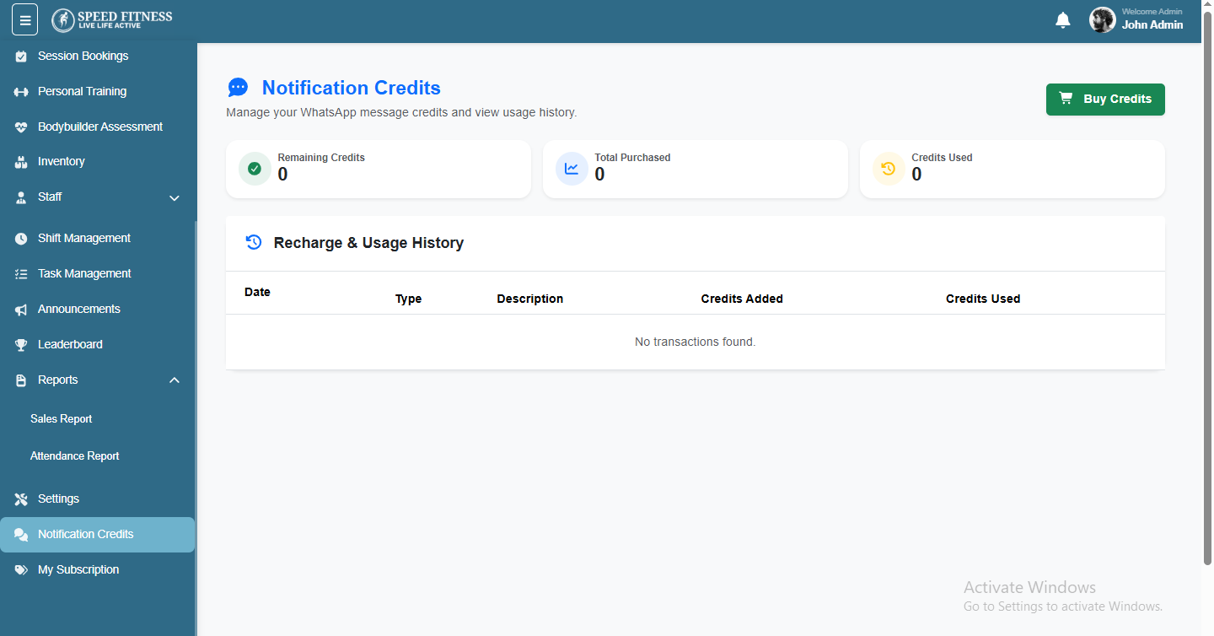
) Inventory & Equipment Management Module
Gym owners can maintain a complete digital inventory of all equipment, accessories, and operational items available in their facility. The system will help track available assets, monitor stock levels, and identify items that need maintenance, replacement, or replenishment.

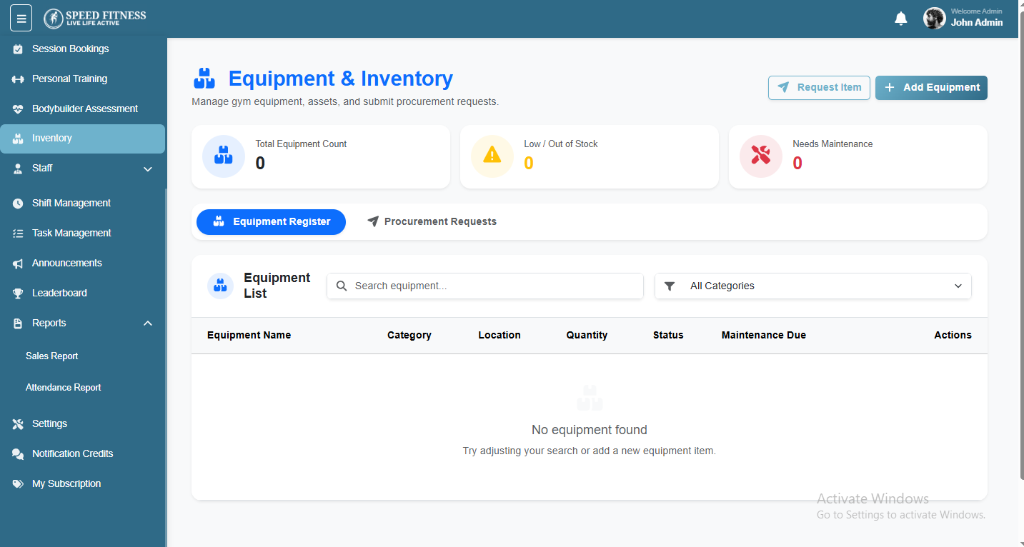

- Trainers
Workout Builder

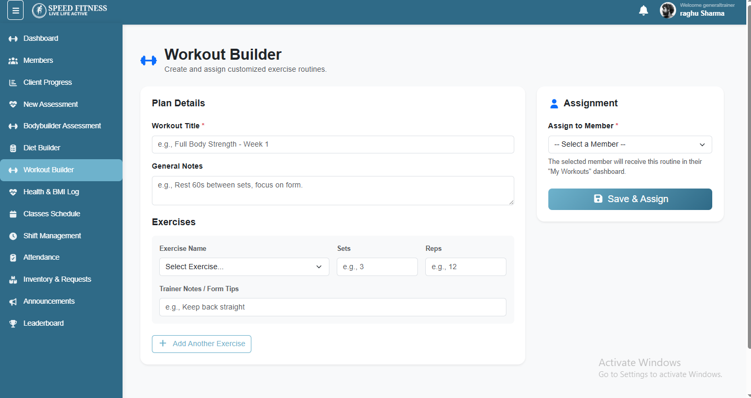
Equipment & Inventory

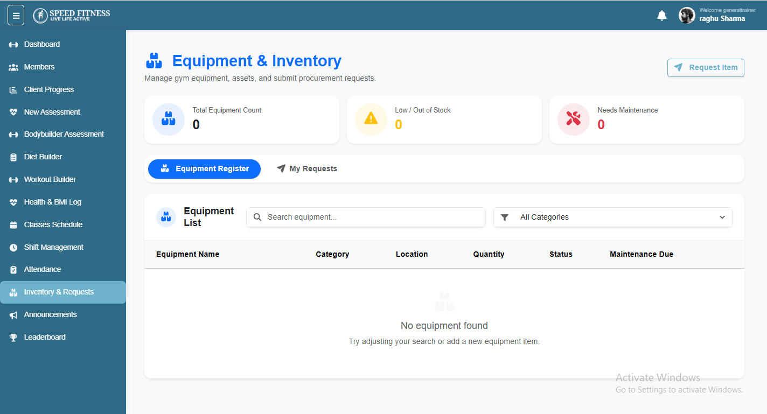

To make your GymCatalyst system fully live and automated, you will need to purchase the following APIs:
1. Email SMTP Service (Required) This is needed to send all automated emails from the system — such as invoices, membership reminders, attendance alerts, and announcements.
Recommended options: SendGrid, Amazon SES, or Hostinger Business Email.
2. WhatsApp Business API (Optional) If you want to send automated WhatsApp messages to your members (like renewal reminders, payment receipts, etc.), you will need a WhatsApp Business API.
Recommended options: Wati, Interakt, or Twilio WhatsApp.
Once you purchase and share the credentials, we will integrate them into the system immediately.
Let us know if you have any questions!

